3/16/2026
LAB NO 06
MOBILE COMPUTING
Submitted to: Sir Haris
Submitted by: Wasif Ali (245187)

Task 01:
Result:
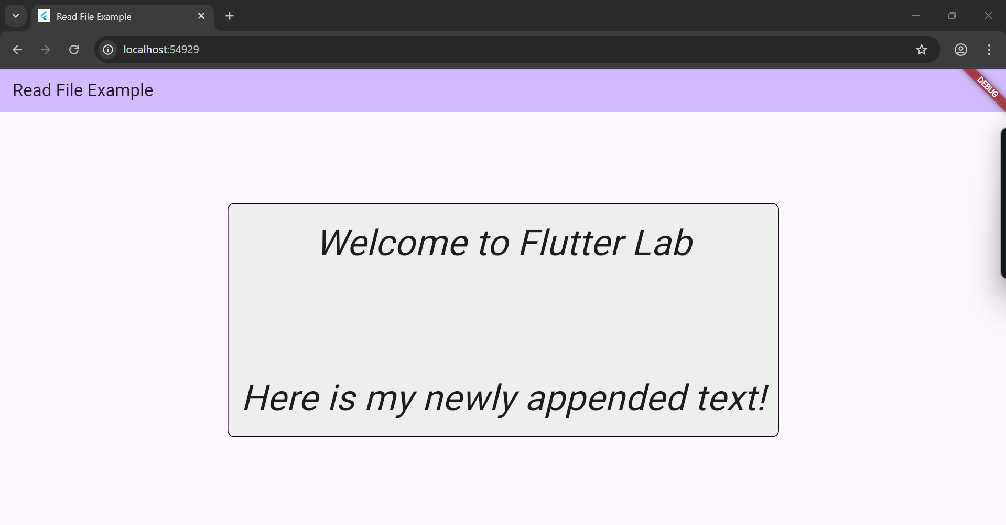

Code:
import 'package:flutter/material.dart';
import 'package:flutter/services.dart' show rootBundle;
void main() {
runApp(const MyApp());
}
class MyApp extends StatelessWidget {
const MyApp({super.key});
@override
Widget build(BuildContext context) {
return MaterialApp(
title: 'Read File Example',
theme: ThemeData(
colorScheme: ColorScheme.fromSeed(seedColor: Colors.deepPurple),
useMaterial3: true,
),
home: const MyHomePage(title: 'Read File Example'),
);
}
}
class MyHomePage extends StatefulWidget {
const MyHomePage({super.key, required this.title});
final String title;
@override
State<MyHomePage> createState() => _MyHomePageState();
}
class _MyHomePageState extends State<MyHomePage> {
String fileContent = "Loading...";
@override
void initState() {
super.initState();
readTextFile();
}
Future<void> readTextFile() async {
try {
String content = await rootBundle.loadString('assets/simple.txt');
setState(() {
// 1. APPENDING TEXT HERE:
// \n creates a new line before your appended text
fileContent = content + "\n\nHere is my newly appended text!";
});
} catch (e) {
setState(() {
fileContent = "Error loading file";
});
}
}
@override
Widget build(BuildContext context) {
return Scaffold(
appBar: AppBar(
title: Text(widget.title),
backgroundColor: Theme.of(context).colorScheme.inversePrimary,
),
body: Center(
child: Container(
padding: const EdgeInsets.all(16.0),
decoration: BoxDecoration(
color: Colors.grey[200],
borderRadius: BorderRadius.circular(8.0),
border: Border.all(color: Colors.black),
),
child: Text(
fileContent,
// 2. UPDATING FONT SIZE AND STYLE HERE:
style: const TextStyle(
fontSize: 46, // Increased font size
fontStyle: FontStyle.italic, // Made the text italic
),
textAlign: TextAlign.center,
),
),
),
);
}
}

Task 02:
Result:
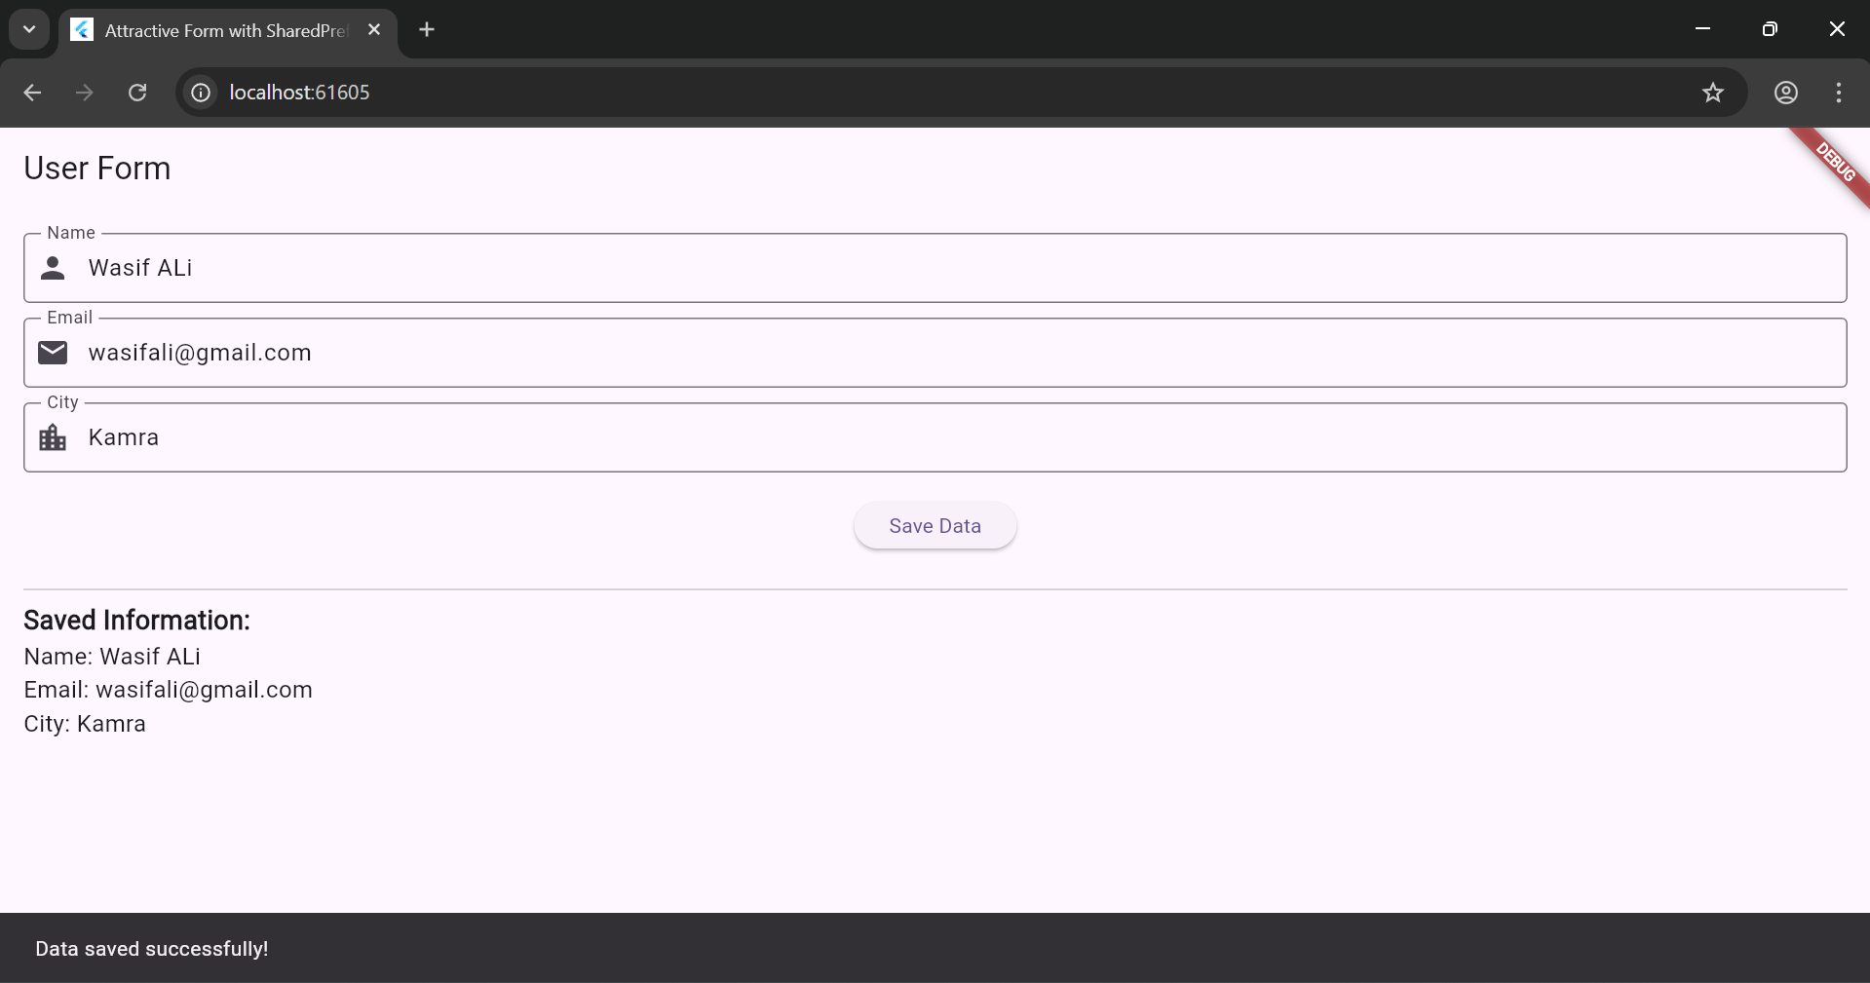
Code:
import 'package:flutter/material.dart';
import 'package:shared_preferences/shared_preferences.dart';
void main() { runApp(const MyApp());
}
class MyApp extends StatelessWidget { const MyApp({super.key});
@override
Widget build(BuildContext context) { return MaterialApp(
title: 'Attractive Form with SharedPreferences', theme: ThemeData(
colorScheme: ColorScheme.fromSeed(seedColor: Colors.deepPurple), useMaterial3: true,
),
home: const FormPage(),
);
}
}
class FormPage extends StatefulWidget { const FormPage({super.key});
@override
State<FormPage> createState() => _FormPageState();
}
class _FormPageState extends State<FormPage> {
final TextEditingController _nameController = TextEditingController();
final TextEditingController _emailController = TextEditingController();
final TextEditingController _cityController = TextEditingController();
String _retrievedName = '';
String _retrievedEmail = '';
String _retrievedCity = '';
@override
void initState() { super.initState();
_loadSavedData();
}
Future<void> _loadSavedData() async {
final prefs = await SharedPreferences.getInstance();
setState(() {
_retrievedName = prefs.getString('name') ?? 'Not saved yet';
_retrievedEmail = prefs.getString('email') ?? 'Not saved yet';
_retrievedCity = prefs.getString('city') ?? 'Not saved yet';
});
}
Future<void> _saveData() async {
final prefs = await SharedPreferences.getInstance();
await prefs.setString('name', _nameController.text);
await prefs.setString('email', _emailController.text);
await prefs.setString('city', _cityController.text);
_loadSavedData();
}
@override
Widget build(BuildContext context) { return Scaffold(
appBar: AppBar(title: const Text('User Form')),
body: Padding(
padding: const EdgeInsets.all(16.0), child: Column(
crossAxisAlignment: CrossAxisAlignment.start, children: [
TextField(
controller: _nameController, decoration: InputDecoration(
labelText: 'Name',
border: OutlineInputBorder(), prefixIcon: Icon(Icons.person),
),
),
const SizedBox(height: 10),
TextField(
controller: _emailController, decoration: InputDecoration(
labelText: 'Email',
border: OutlineInputBorder(), prefixIcon: Icon(Icons.email),
),
),
const SizedBox(height: 10),
TextField(
controller: _cityController, decoration: InputDecoration(
labelText: 'City',
border: OutlineInputBorder(), prefixIcon: Icon(Icons.location_city),
),
),
const SizedBox(height: 20),
Center(
child: ElevatedButton( onPressed: () {
_saveData();
ScaffoldMessenger.of(context).showSnackBar(
const SnackBar(content: Text('Data saved successfully!')),
);
},
child: const Text('Save Data'),
),
),
const SizedBox(height: 20), const Divider(),
const Text(
'Saved Information:',
style: TextStyle(fontSize: 18, fontWeight: FontWeight.bold),
),
Text('Name: $_retrievedName', style: TextStyle(fontSize: 16)),
Text('Email: $_retrievedEmail', style: TextStyle(fontSize: 16)),
Text('City: $_retrievedCity', style: TextStyle(fontSize: 16)),
],
),
),
);
}
@override
void dispose() {
_nameController.dispose();
_emailController.dispose();
_cityController.dispose();
super.dispose();
}
}

Task 03:
Result:
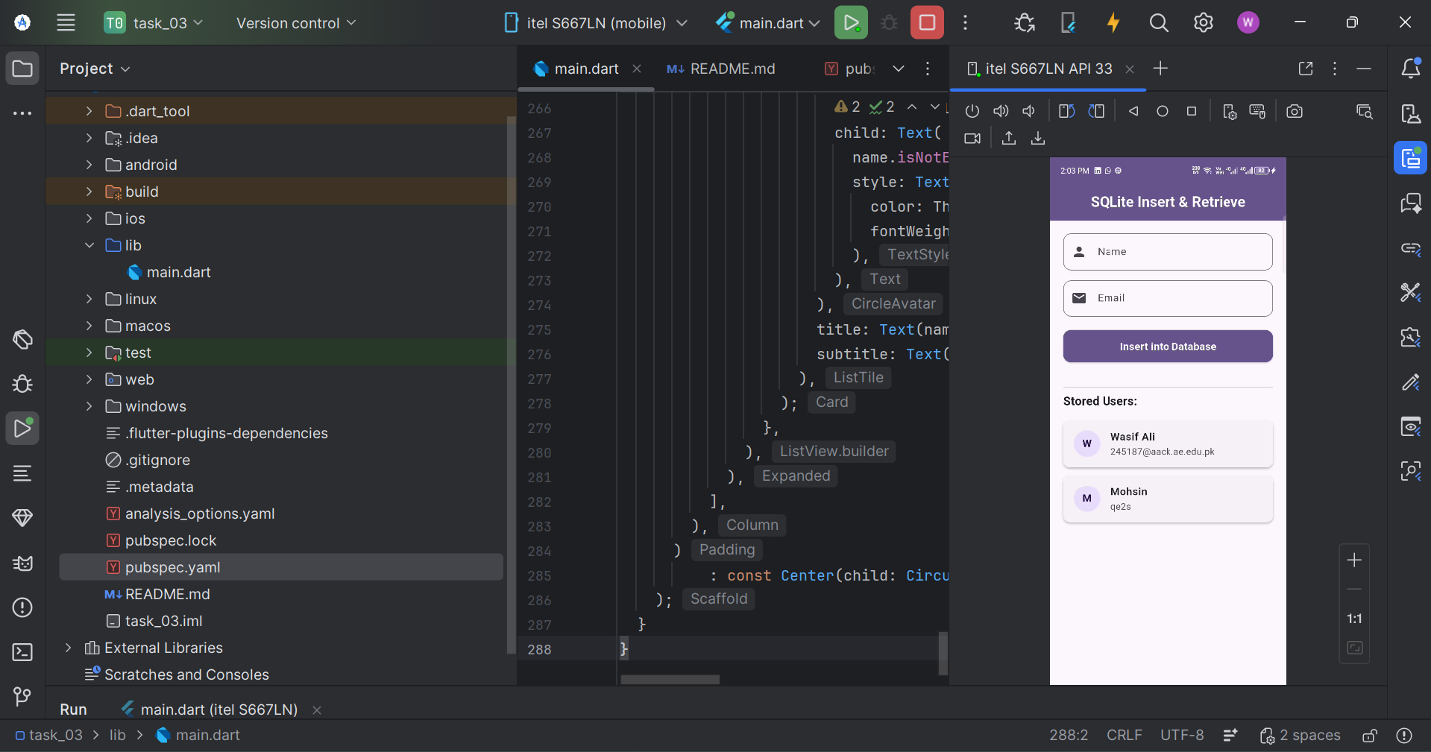

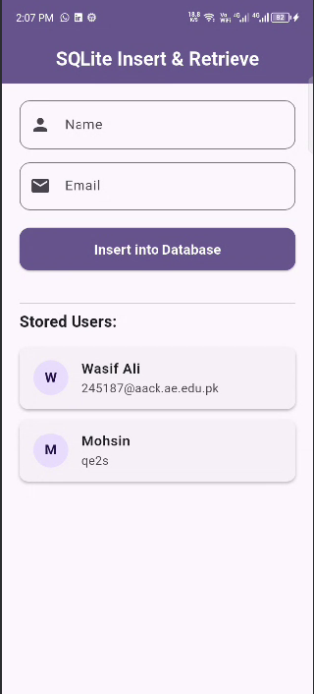
Code:
import 'package:flutter/material.dart';
import 'package:sqflite/sqflite.dart';
import 'package:path/path.dart';
import 'package:path_provider/path_provider.dart';
import 'dart:io';
void main() async {
// Required because we are initializing the database before runApp
WidgetsFlutterBinding.ensureInitialized();
runApp(const MyApp());
}
class MyApp extends StatelessWidget {
const MyApp({super.key});
@override
Widget build(BuildContext context) {
return MaterialApp(
title: 'SQLite Debugging Demo',
debugShowCheckedModeBanner: false, // Removes the debug banner
theme: ThemeData(
colorScheme: ColorScheme.fromSeed(seedColor: Colors.deepPurple),
useMaterial3: true,
),
home: const MyHomePage(title: 'SQLite Insert & Retrieve'),
);
}
}
class MyHomePage extends StatefulWidget {
const MyHomePage({super.key, required this.title});
final String title;
@override
State<MyHomePage> createState() => _MyHomePageState();
}
class _MyHomePageState extends State<MyHomePage> {
Database? _database;
final TextEditingController _nameController = TextEditingController();
final TextEditingController _emailController = TextEditingController();
List<Map<String, dynamic>> _users = [];
bool _isDatabaseInitialized = false;
String? _errorMessage;
@override
void initState() {
super.initState();
_initializeDatabase();
}
Future<void> _initializeDatabase() async {
try {
debugPrint('Starting database initialization...');
setState(() {
_isDatabaseInitialized = false;
_errorMessage = null;
});
Directory documentsDirectory = await getApplicationDocumentsDirectory();
String path = join(documentsDirectory.path, 'users.db');
debugPrint('Database Path: $path');
_database = await openDatabase(
path,
version: 1,
onCreate: (db, version) async {
await db.execute(
'CREATE TABLE users(id INTEGER PRIMARY KEY AUTOINCREMENT, name TEXT, email TEXT)',
);
},
);
if (_database == null) {
throw Exception('Database failed to initialize.');
}
await _retrieveUsers();
setState(() {
_isDatabaseInitialized = true;
});
} catch (e) {
setState(() {
_isDatabaseInitialized = false;
_errorMessage = 'Database Error: $e';
});
}
}
Future<void> _insertUser(BuildContext context, String name, String email) async {
if (_database == null) {
ScaffoldMessenger.of(context).showSnackBar(
const SnackBar(content: Text('Database is not initialized!')),
);
return;
}
try {
int result = await _database!.insert(
'users',
{'name': name, 'email': email},
conflictAlgorithm: ConflictAlgorithm.replace,
);
if (result > 0) {
await _retrieveUsers(); // Refresh the list
ScaffoldMessenger.of(context).showSnackBar(
const SnackBar(
content: Text('User added successfully'),
backgroundColor: Colors.green,
),
);
} else {
ScaffoldMessenger.of(context).showSnackBar(
const SnackBar(
content: Text('Error: User was not inserted.'),
backgroundColor: Colors.red,
),
);
}
} catch (e) {
debugPrint('Error inserting user: $e');
}
}
Future<void> _retrieveUsers() async {
if (_database == null) return;
try {
final List<Map<String, dynamic>> users = await _database!.query('users');
setState(() {
_users = users;
});
} catch (e) {
debugPrint('Error retrieving users: $e');
}
}
@override
Widget build(BuildContext context) {
return Scaffold(
appBar: AppBar(
title: Text(widget.title, style: const TextStyle(fontWeight: FontWeight.bold, color: Colors.white)),
backgroundColor: Theme.of(context).colorScheme.primary,
centerTitle: true,
elevation: 0,
),
body: _errorMessage != null
? Center(
child: Column(
mainAxisAlignment: MainAxisAlignment.center,
children: [
const Icon(Icons.error, color: Colors.red, size: 50),
const SizedBox(height: 10),
Text(
_errorMessage!,
textAlign: TextAlign.center,
style: const TextStyle(color: Colors.red, fontSize: 16),
),
const SizedBox(height: 10),
ElevatedButton.icon(
onPressed: _initializeDatabase,
icon: const Icon(Icons.refresh),
label: const Text('Retry Database Initialization'),
),
],
),
)
: _isDatabaseInitialized
? Padding(
padding: const EdgeInsets.all(20.0),
child: Column(
crossAxisAlignment: CrossAxisAlignment.start,
children: [
// --- FORM SECTION ---
TextField(
controller: _nameController,
decoration: InputDecoration(
labelText: 'Name',
prefixIcon: const Icon(Icons.person),
border: OutlineInputBorder(
borderRadius: BorderRadius.circular(12),
),
),
),
const SizedBox(height: 15),
TextField(
controller: _emailController,
decoration: InputDecoration(
labelText: 'Email',
prefixIcon: const Icon(Icons.email),
border: OutlineInputBorder(
borderRadius: BorderRadius.circular(12),
),
),
keyboardType: TextInputType.emailAddress,
),
const SizedBox(height: 20),
// --- BUTTON SECTION ---
SizedBox(
width: double.infinity,
height: 50,
child: ElevatedButton(
style: ElevatedButton.styleFrom(
backgroundColor: Theme.of(context).colorScheme.primary,
foregroundColor: Colors.white,
shape: RoundedRectangleBorder(
borderRadius: BorderRadius.circular(12),
),
),
onPressed: () {
if (_nameController.text.isNotEmpty &&
_emailController.text.isNotEmpty) {
_insertUser(context, _nameController.text, _emailController.text);
_nameController.clear();
_emailController.clear();
// Hide keyboard after inserting
FocusScope.of(context).unfocus();
} else {
ScaffoldMessenger.of(context).showSnackBar(
const SnackBar(
content: Text('Please enter both name and email'),
backgroundColor: Colors.orange,
),
);
}
},
child: const Text(
'Insert into Database',
style: TextStyle(fontSize: 16, fontWeight: FontWeight.bold),
),
),
),
const SizedBox(height: 30),
const Divider(),
// --- LIST SECTION ---
const Text(
'Stored Users:',
style: TextStyle(fontSize: 18, fontWeight: FontWeight.bold),
),
const SizedBox(height: 10),
Expanded(
child: _users.isEmpty
? Center(
child: Text(
'No users found. Add someone!',
style: TextStyle(color: Colors.grey.shade600),
),
)
: ListView.builder(
itemCount: _users.length,
itemBuilder: (context, index) {
final user = _users[index];
final name = user['name'] as String;
final email = user['email'] as String;
return Card(
elevation: 2,
margin: const EdgeInsets.symmetric(vertical: 6),
shape: RoundedRectangleBorder(
borderRadius: BorderRadius.circular(10),
),
child: ListTile(
leading: CircleAvatar(
backgroundColor: Theme.of(context).colorScheme.primaryContainer,
child: Text(
name.isNotEmpty ? name[0].toUpperCase() : '?',
style: TextStyle(
color: Theme.of(context).colorScheme.onPrimaryContainer,
fontWeight: FontWeight.bold,
),
),
),
title: Text(name, style: const TextStyle(fontWeight: FontWeight.w600)),
subtitle: Text(email),
),
);
},
),
),
],
),
)
: const Center(child: CircularProgressIndicator()),
);
}
}

